Project „Dealing with Gifted Education” fourth meeting Summary
by Riina Tamm, Pirita Majandusgümnaasium

We had 15 respondents answering as followed:
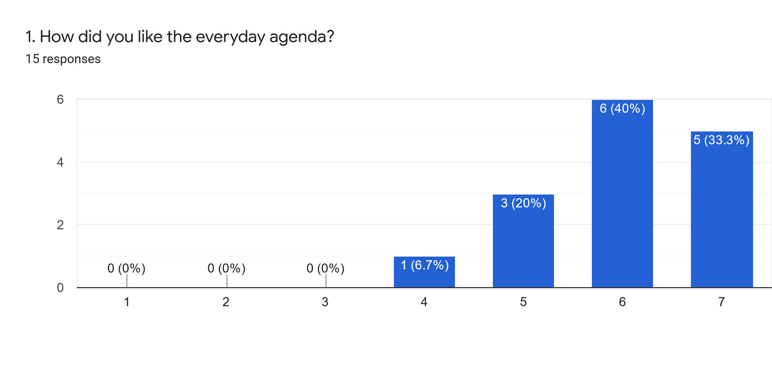
Comments:
We have visited very interesting places
The agenda was very interesting and useful for the all participants, in 100% relation with the main project topic
A little bit full
A little bit hard and tiring.
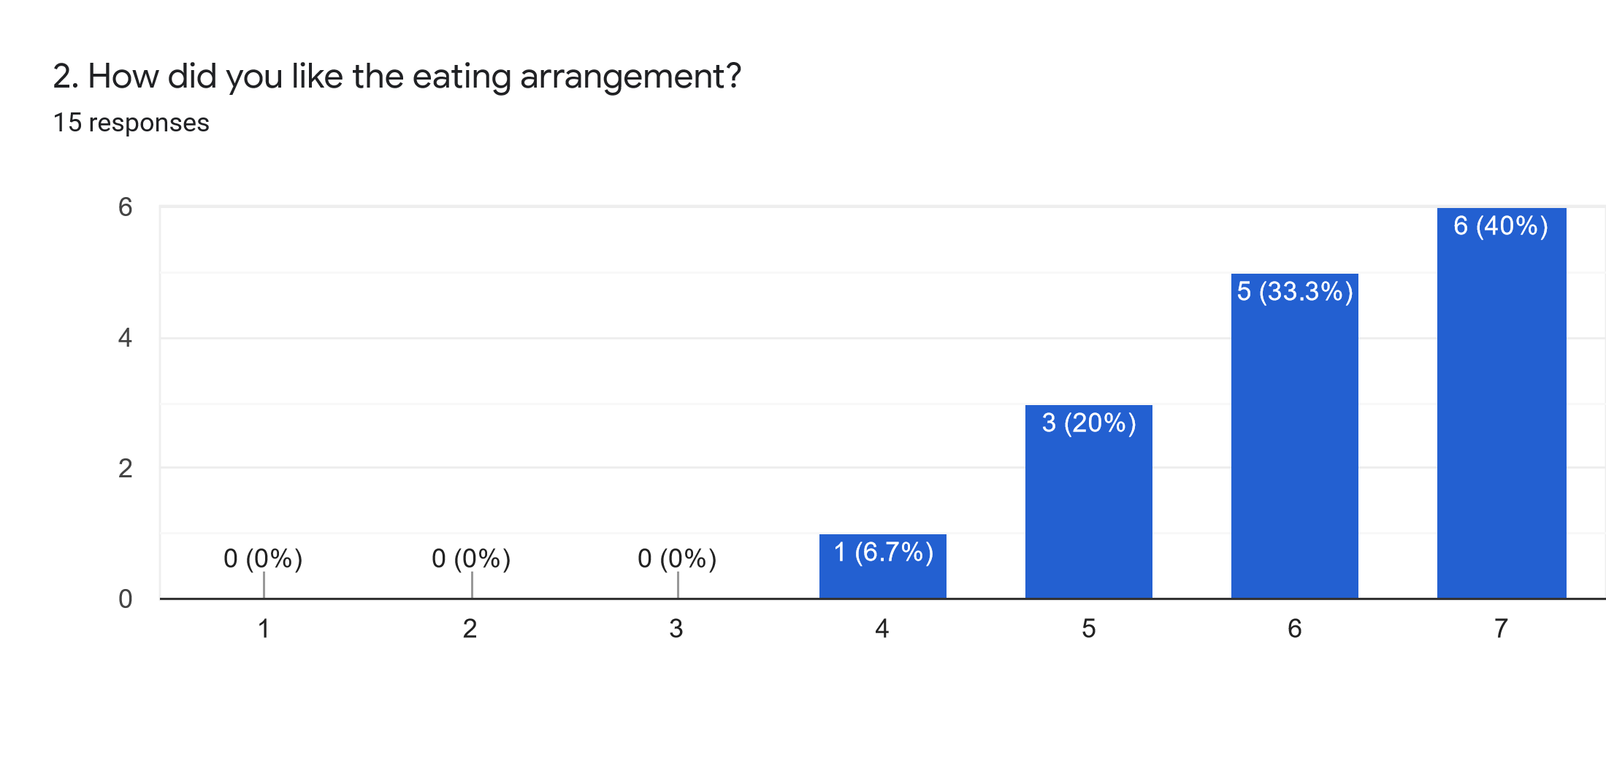
Comments:
Great foods, very good elections
in General the food was delicious, but different than my taste. sometime too modern and mixed salty and sweet

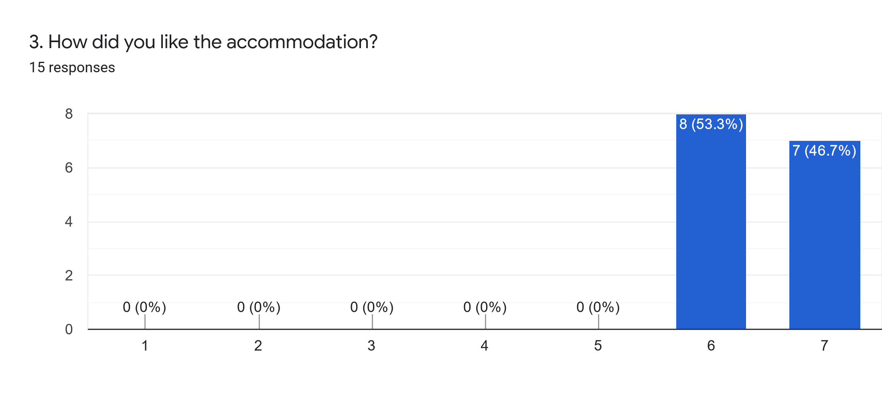
Comments:
Confortable, very nice breakfast, easy to arrive
Nice and comfortable hotel, near to the school and polite personal
Comfortable, cosy, quiet - perfect

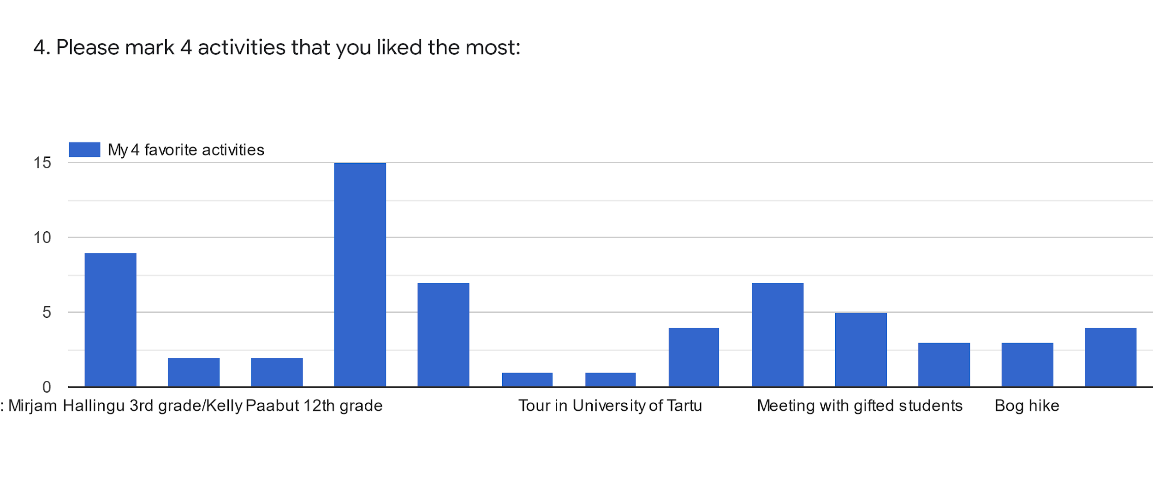
4.1 Top three of most liked activities was:
Visit to Gustav Adolf Grammar School - 15 persons
Visiting open lessons: Mirjam Hallingu 3rd grade/Kelly Paabut 12th grade - 9 persons
Robotics workshop lead by Students of Gustav Adolf Grammar School - 7 persons
Film session “La famille Bélier” and discussion - 7 persons

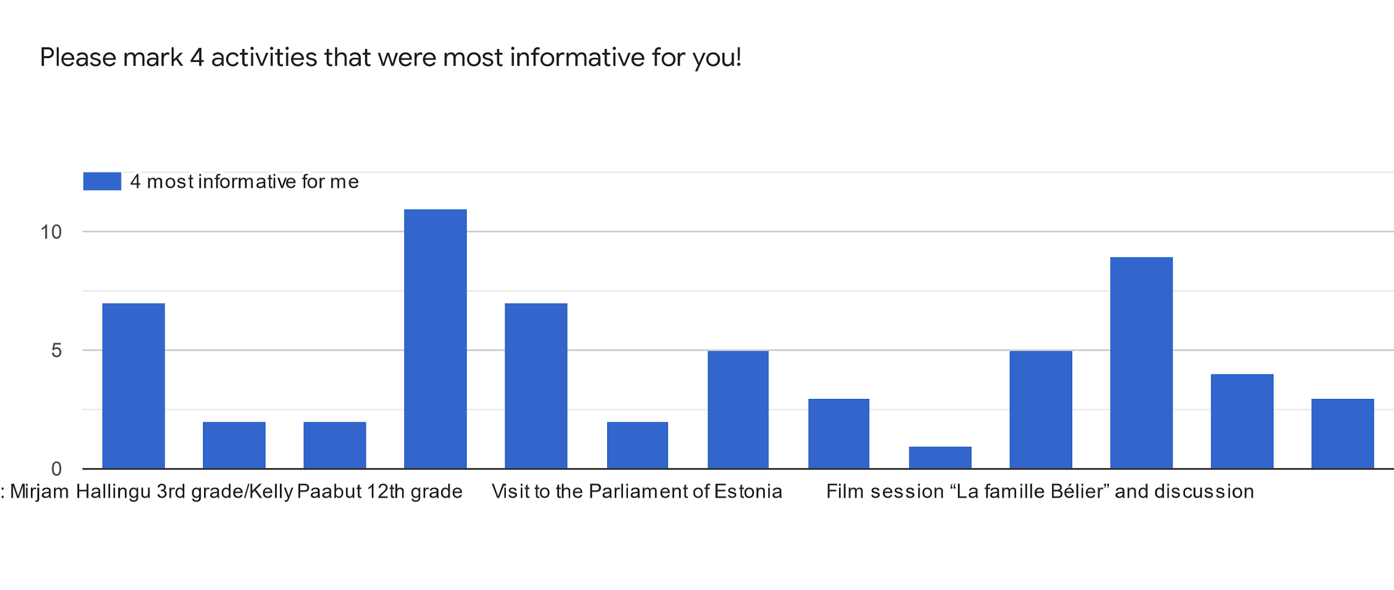

4.2 Top three of most informative activities were:
Visit to Gustav Adolf Grammar School - 11 persons
Meeting with gifted students - 9 persons
Visiting open lessons: Mirjam Hallingu 3rd grade/Kelly Paabut 12th grade - 7 persons
Robotics workshop lead by Students of Gustav Adolf Grammar School - 7 persons

Columns from left to right:
Visiting open lessons: Mirjam Hallingu 3rd grade/Kelly Paabut 12th grade
Visit to Pirita district government, Mr Tõnis Liinat
Visit to Pirita Convent, Ms Lagle Parek
Visit to Gustav Adolf Grammar School
Robotics workshop lead by Students of Gustav Adolf Grammar School
Visit to the Parliament of Estonia
Visit to the Tartu University Science School
Tour in University of Tartu
Science Center AHHAA/CSI: DNA extraction workshop
Film session “La famille Bélier” and discussion
Meeting with gifted students
Seminar Gifted Students' Underachievement by Ms Viire Sepp (University of Tartu)
Bog hike
Visit to Käsmu maritime museum

Comments:
The seminar topic was crucial. lt would be very useful to have the powerpoint in English.
Questions 3 and 4 are not easy to answer. There are mixed categories that I can't compare.
The all activities were very interesting and useful

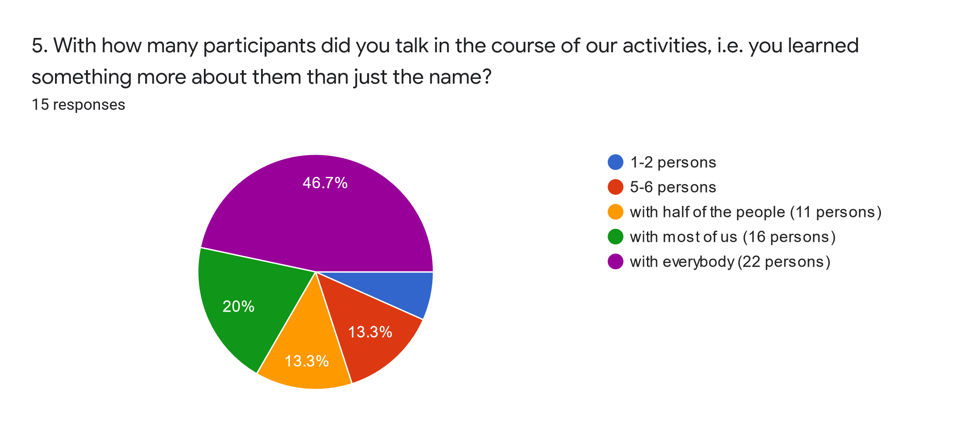
Comments:
Each time is easier to talk to everyone.
Next time I will try to talk with all of the participants, but this time I could not deal with this task (unfortunately)

6. To secure a successful outcome for our project, I would suggest…
I think the project is going quite well. If the participants read and explore more by themselves it may be more productive...Also the participant can be more active to explain the aspects of being gifted..
To have some periods to discuss on the topic of gifted students during the Bulgarian and Romanian meeting.
More time for change experience with gifted pupils.
Nothing, I liked the whole experience very much!
Make the week of the program less stressful.
A more relaxing programme so that we have the chance to communicate with partners and get asense of the local culture. Some more discussions or activities about the concept of the programme.

