Project „Dealing with Gifted Education” second meeting Summary
by Riina Tamm, Pirita Majandusgümnaasium

We had 12 respondents answering as followed:

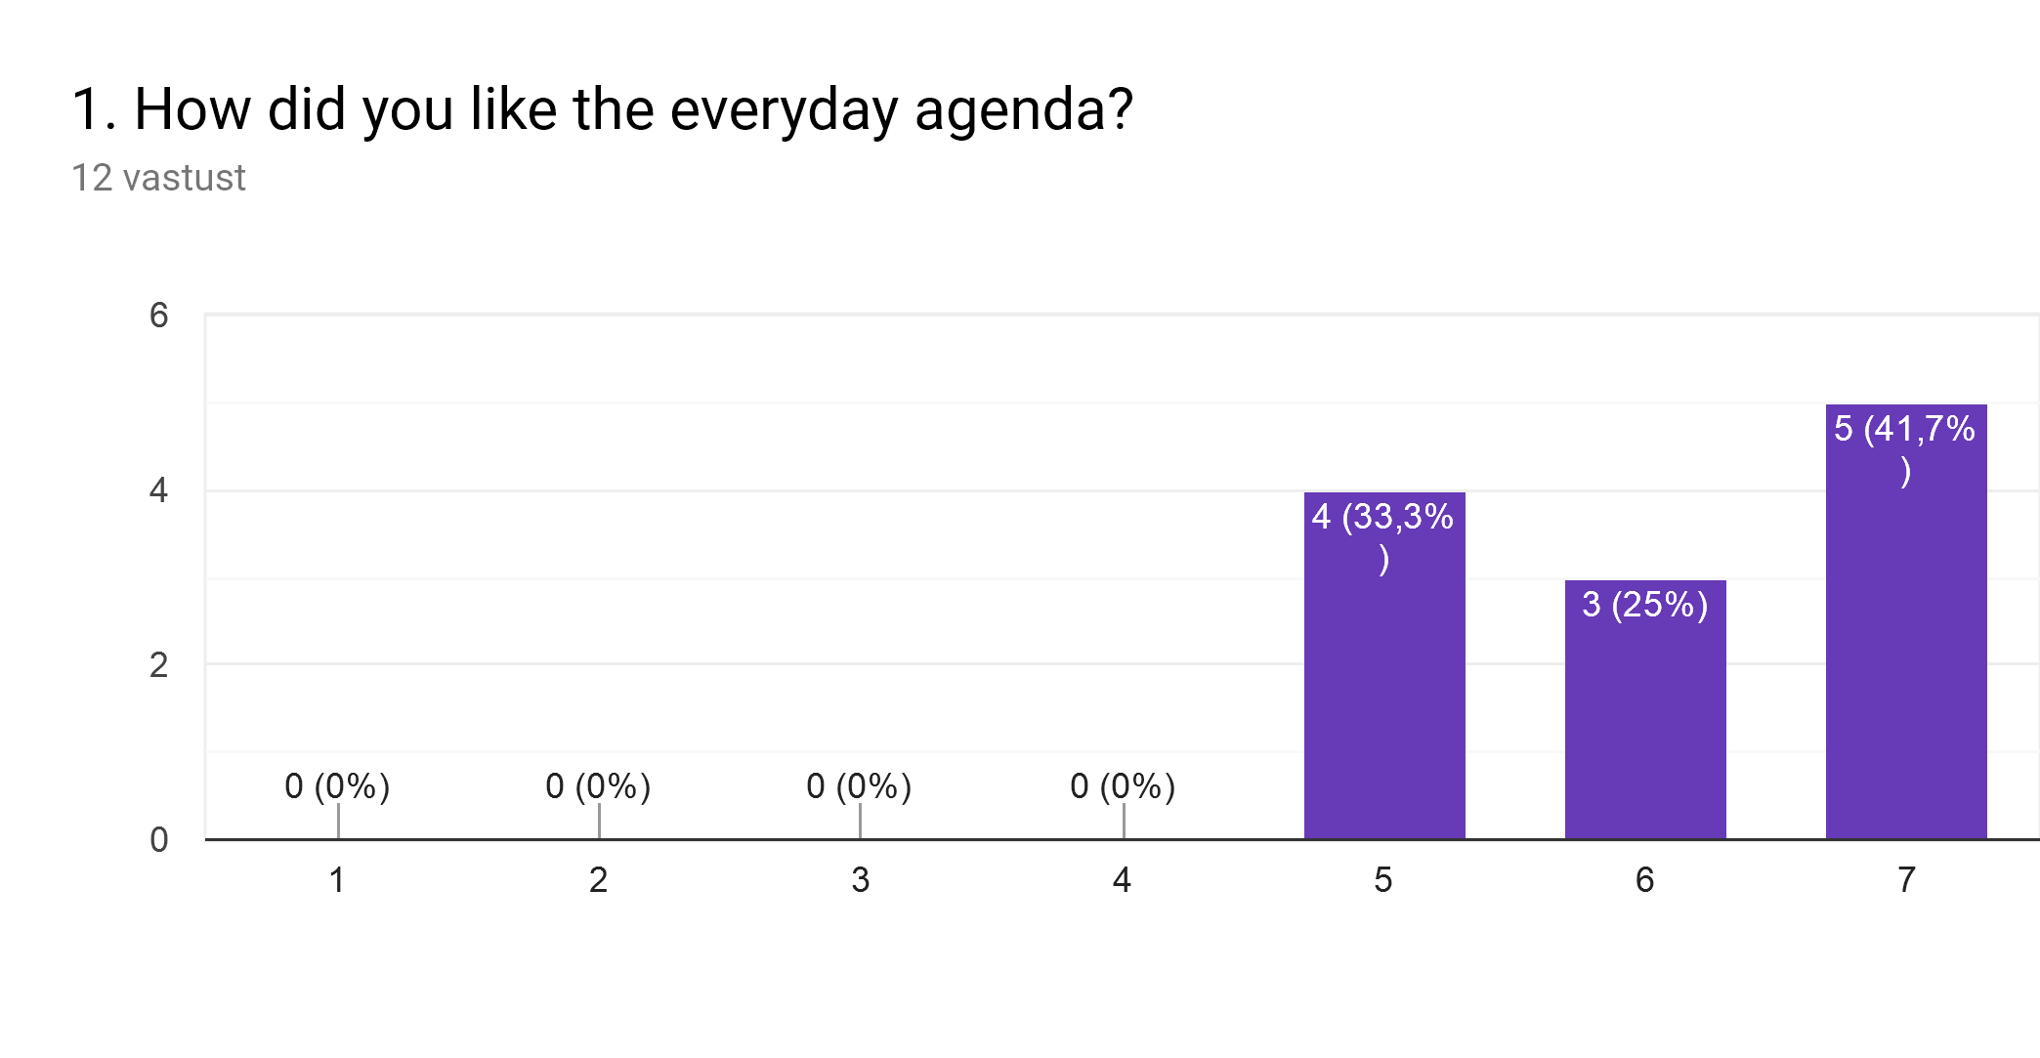
Comments:

I would have liked more time to share views and project.
Few activities based on the purpose of the project

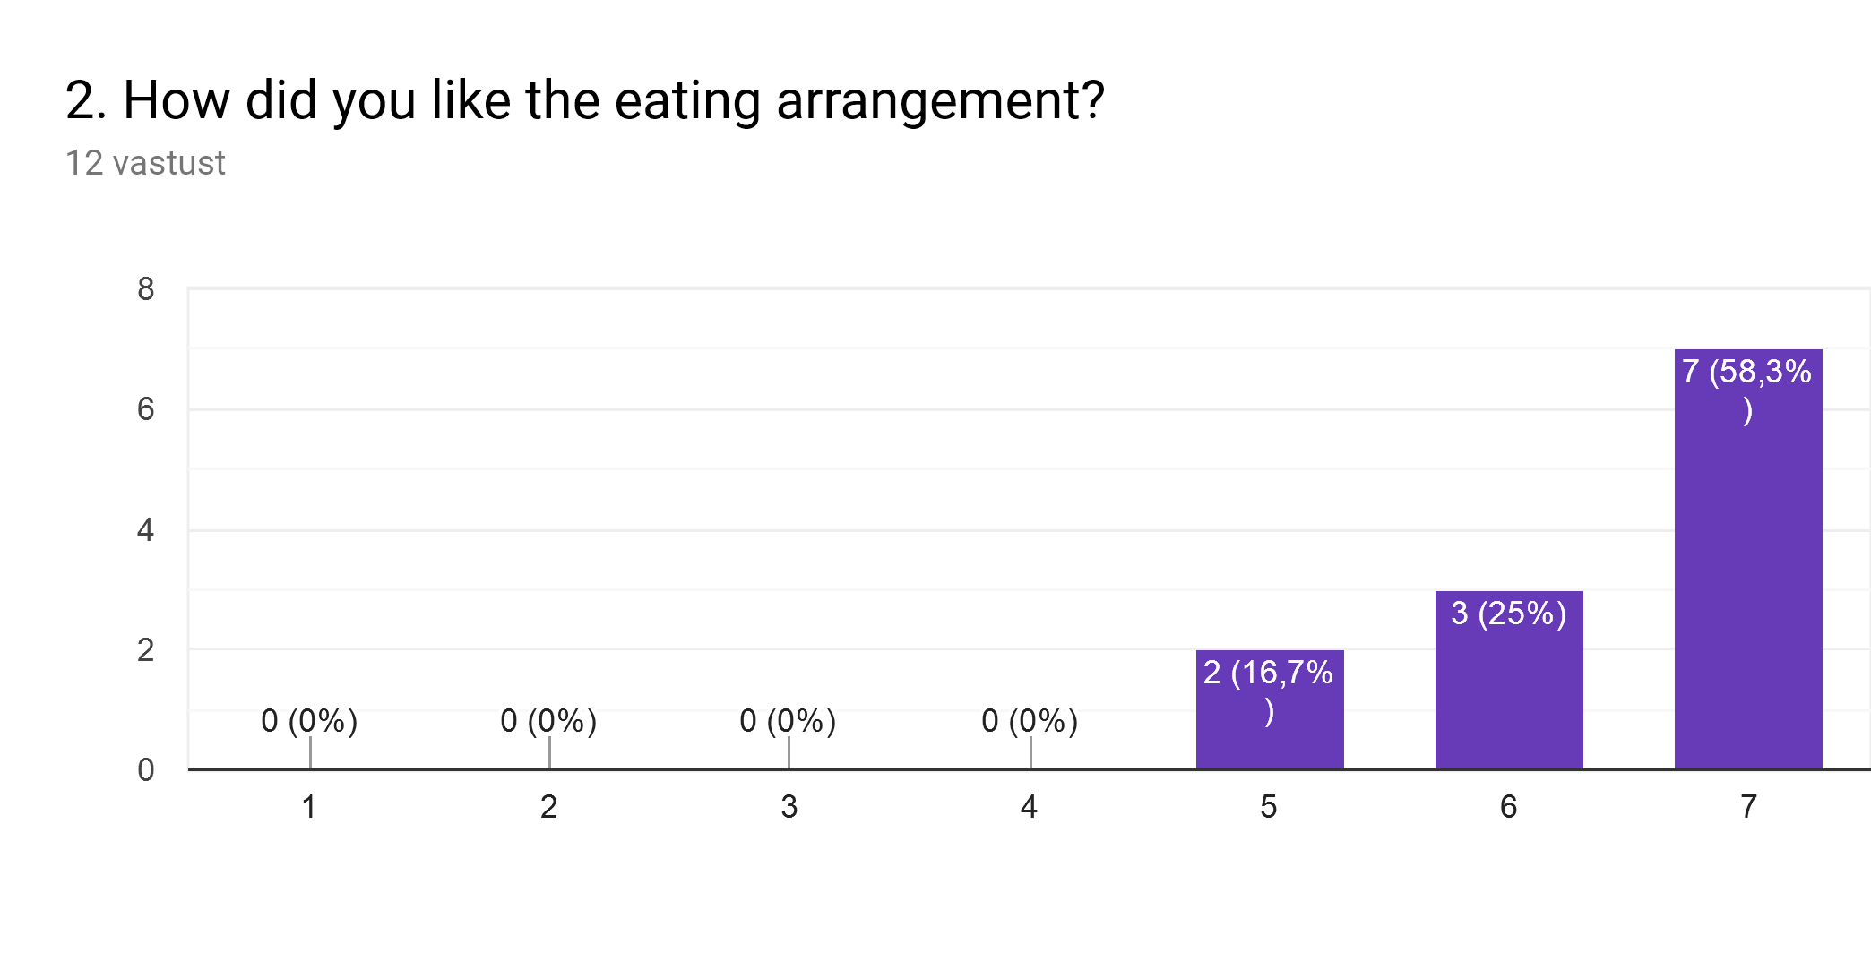
Comments:

Great. Thank you very much to our hosts
Very good idea to prepare an invoice for each country with all the meals included
Three lunches in the same restaurant with the same menu wasn’t very good
Food was very good but portions was quit big. Usually we don`t eat so mutch.

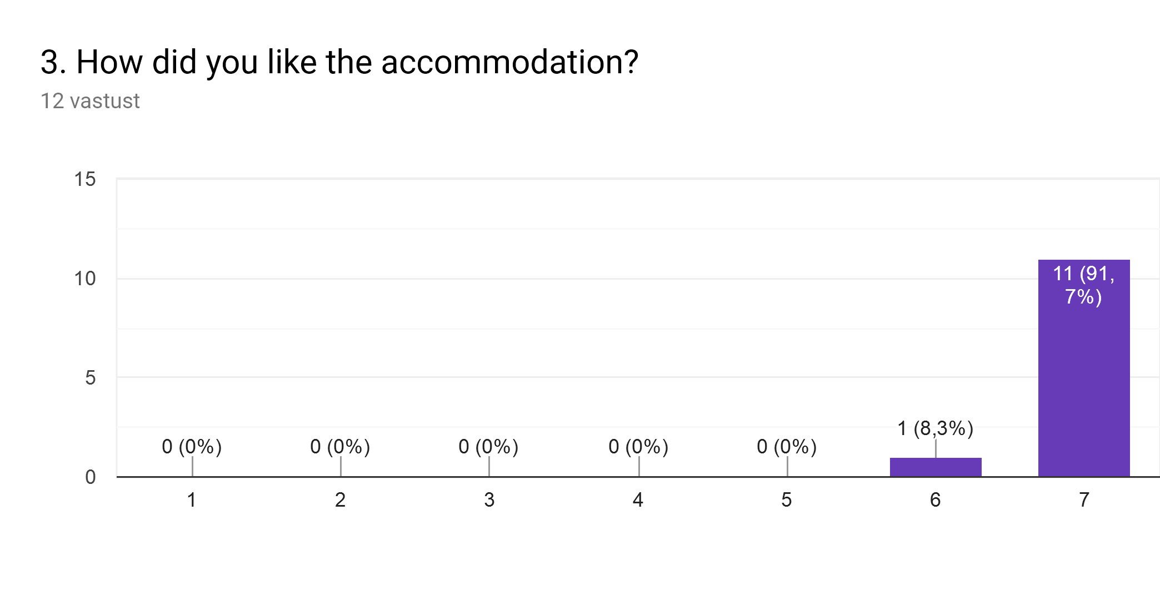
Comments:

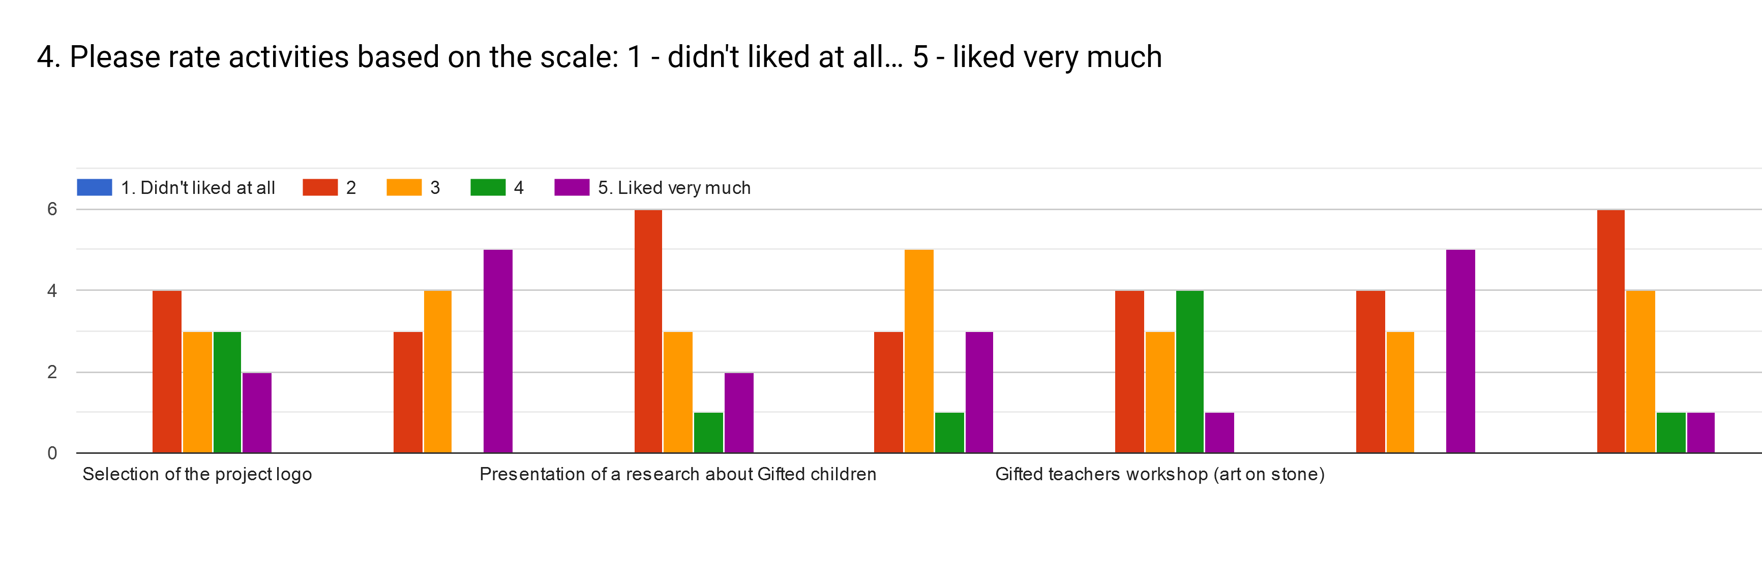
Columns from left to right:
1. Selection of the project logo
2. Presentation of 5 famous scientists
3. Presentation of a research about Gifted children
4. Presentation from Greek Mathematical Society
5. Gifted teachers workshop (art on stone)
6. Film Forum «Gifted»
7. Seminar in University of Thessaly "Gifted students: Features and teaching support" (by Stavroula Kaldi and Theodoros Kokkinos)

Most liked were:
Presentation of 5 famous scientists - liked very much: 5 votes
Film Forum „Gifted” - liked very much: 5 votes
Gifted teachers workshop (art on stone) - liked very much: 1 vote, liked it: 4 votes

Seminar in University of Thessaly "Gifted students: Features and teaching support" (by Stavroula Kaldi and Theodoros Kokkinos) - didn’t liked it: 6 votes, so and so: 4 votes
Presentation of a research about Gifted children - didn’t liked it: 6 votes, so and so: 3 votes

Comments:

I think we could have worked more on the film.
The film was very good but the technical support didn't allow us to see the subtitles. I think we couldn't understand it all
The beginning of activities draged, and it wasted our precious time.

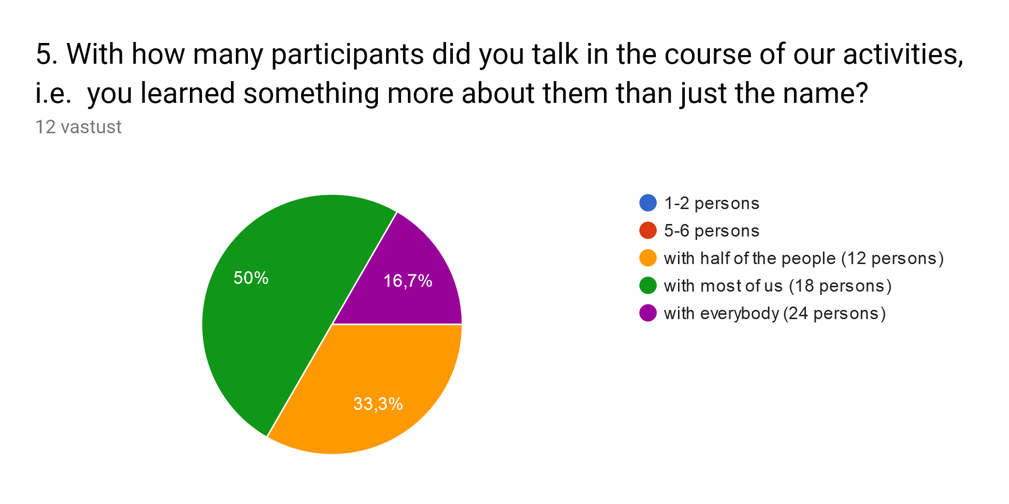

Comments:

Thanks to everyone
Some people is very shy. We should prepare some working teams with mixed groups.
Couldn`t talk to everybody, because some of us weren`t much communicative

For comparsion: from first meeting assesment
