Project „Dealing with Gifted Education” first meeting Summary

We had 11 respondents answering as followed:
1. How did you like the everyday agenda?
7 points of 7 – 9 votes
6 points of 7 – 2 votes

Comments:
Work and pleasure were well balanced.
Everything was just brilliant - location, people, school, meetings, presentations, workshops, trips to other towns, etc. ; even the weather. Just perfect!

Synopsis: Everybody liked everyday agenda very much.
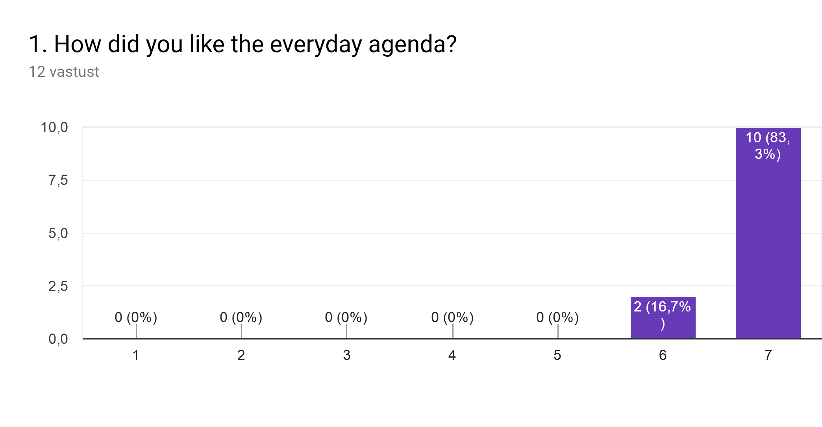

2. How did you like the eating arrangement?
7 points of 7 – 10 votes
6 points of 7 – 1 vote

Comments:
Good assortment and big amounts of food in the dormitory diner!
It was xxcellent with very reasonable price...
Flexible schedule, wide choice, relaxed atmosphere

Synopsis: Everybody liked eating arrangement very much.
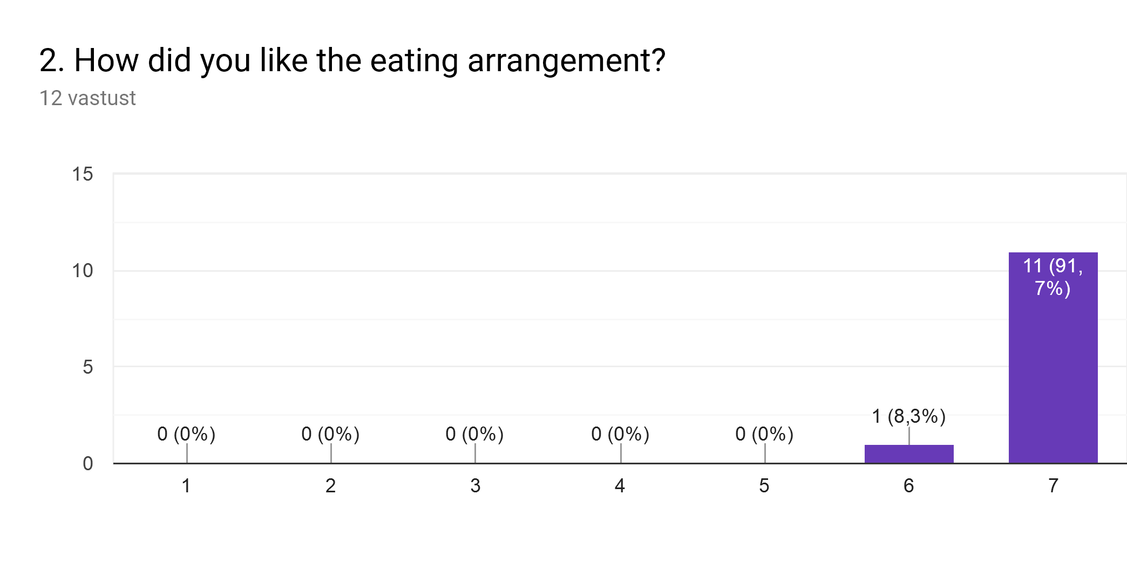

3. How did you like the accommodation?
7 points of 7 – 9 votes
6 points of 7 – 2 votes

Comments:
Clean and trendy place.
Convenient location, excellent price/quality ratio, good neighbours

Synopsis: Everybody liked accommodation arrangement very much.
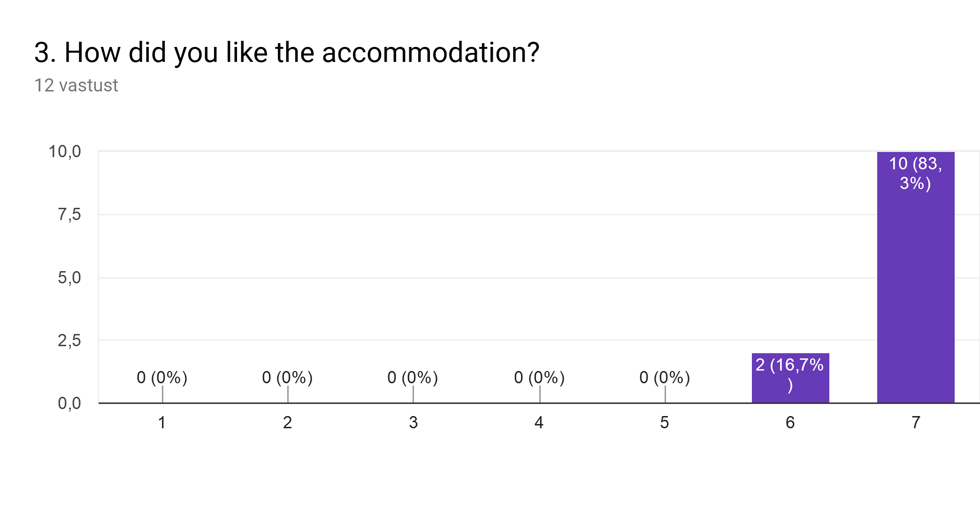

4. Please rate activities based on the scale: 1 - the best… 5 - the least
* Presentation of educational systems and attention to diversity focused on Gifted students in each country – 4 voted for the best
* Seminar on High Abilities issues. (Angeles Bueno) – 10 voted for the best, 1 voted for the least
* Enrichment program presentation. (Jesús Agua) – 5 voted for the best, 1 voted for the least
* Round table with gifted students. - 7 voted for the best, 1 voted for the least
* Film Forum. «Billy Elliot» - 5 voted for the best, 4 voted for the least

Comments:
It's a little bit difficult to assess all the presentations as one (see the grid above); definitely, all of them were interesting, but I have to admit, that I really enjoyed the Spanish presentation most

Synopsis: The most liked activitie was Seminar on High Abilities issues by Angeles Bueno.

5. With how many participants did you talk in the course of our activities, i.e. you learned something more about them than just the name?
1-2 persons – 0
5-6 persons – 2 participants
with half of the people (12 persons) – 6 participants
with most of us (18 persons) – 2 participants
with everybody (24 persons) – 1 participant
Comments:
Probably even more, but unfortunately one week is not a very long time, besides fully packed with activities, therefore it's not easy to make more than 20 new friends :)
Synopsis: Half of the participants say that they managed to get know half of the group.
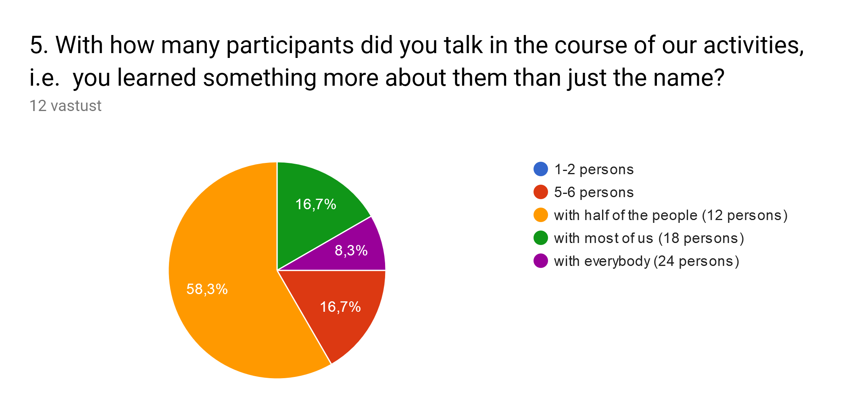

6. Please explain with your own words what the outcome of our project will be!
We will have an overview of the topic and write down recommendations for teachers.
It gave us food for thought concerning the education of gifted students.
It will have the opportunity to learn about the work done in different countries.
The exchange of experience between the project's members believes that it is beneficial for the approach of the activity of each of us. Many of the methods we have encountered during the Spanish activities have already been applied in didactic activity and I think they have made it more attractive for children.
Cultural exchange and learning different educational systems...
I think this project is extremely useful and innovative in the field of the abduction of gifted students. For all teachers, such a course is needed
I learned a lot of useful facts and techniques for developing classes with gifted students. I already apply everything learned and I have no patience for the next part of the training and for everything we will learn by the end of the project
I think that the project will help me to be more confident and effective both in discovering and working with the gifted children. The other very important thing will be the possibility to share experience and useful techniques from now on.
Timely discovering of these children requires flexibility in the teaching process that aims to expanding the knowledge and skills and drawing the attention of the gifted children.
To learn possibilities for creating a system focused on gifted students in each country.
All six participating countries are going to have a lot of highly professional and emotionally intelligent teachers with an individual approach to every student, attentive, able to notice, and ready support and nourish young talents.

7. Are there any aspects of the project that you feel should be more clearly specified?
I'm note sure that I know to well what the outcome of this project will be and how we will achieve it.
Everything was quite clear.
Should the project have a purpose, such as a survey or a curriculum program? Not only have to be voice think...
No
To observe the chance given to the gifted students in different countries
I think that everything is OK.
none at all
Summary: Maybe we should once more talk about the aim and the outcome of the project.

