**Project „Dealing with Gifted Education” second meeting Summary**

We had 12 respondents answering as followed:

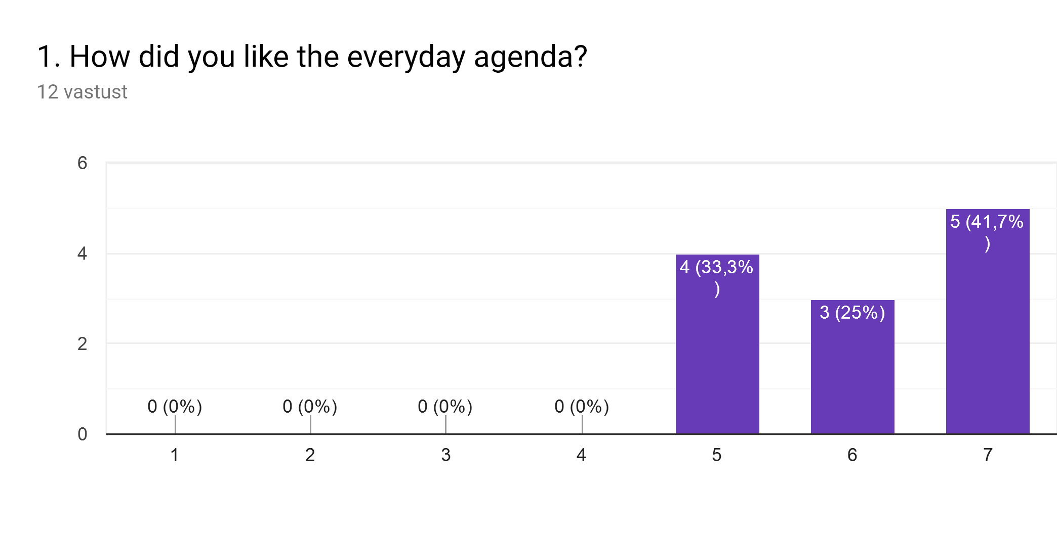

Comments:

I would have liked more time to share viewsand project.

Few activities based on the purpose of the project

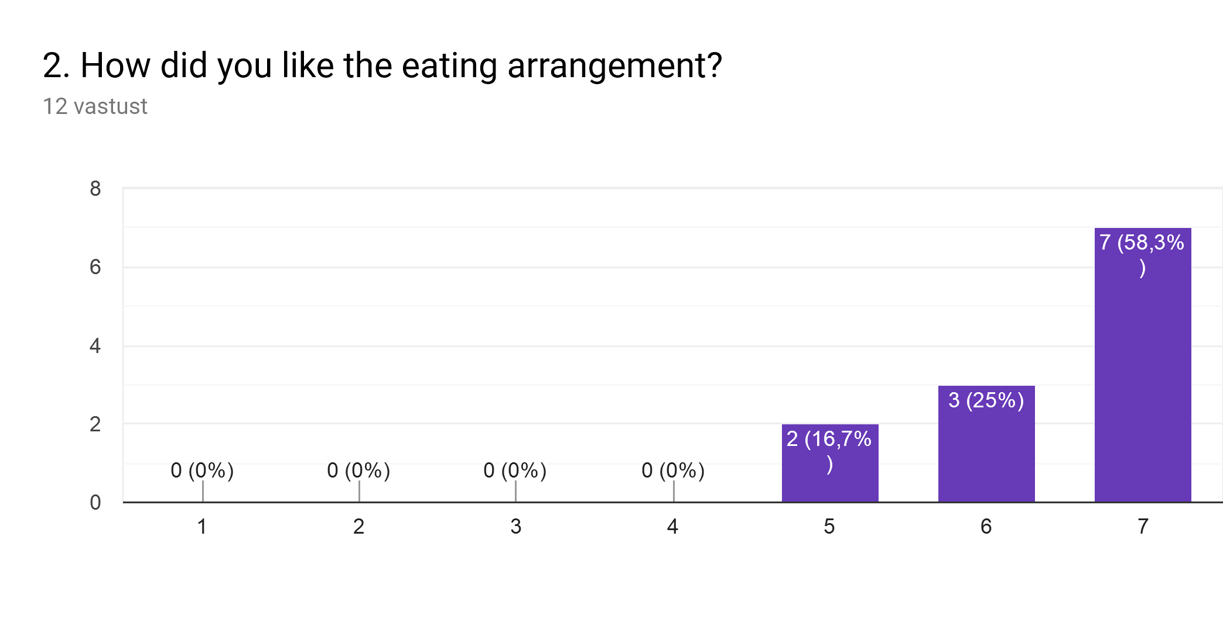

Comments:

Great. Thank you very much to our hosts

Very good idea to prepare an invoice for each country with all the meals included

Three lunches in the same restaurant with the same menu wasn’t very good

Food was very good but portions was quit big. Usually we don`t eat so mutch.

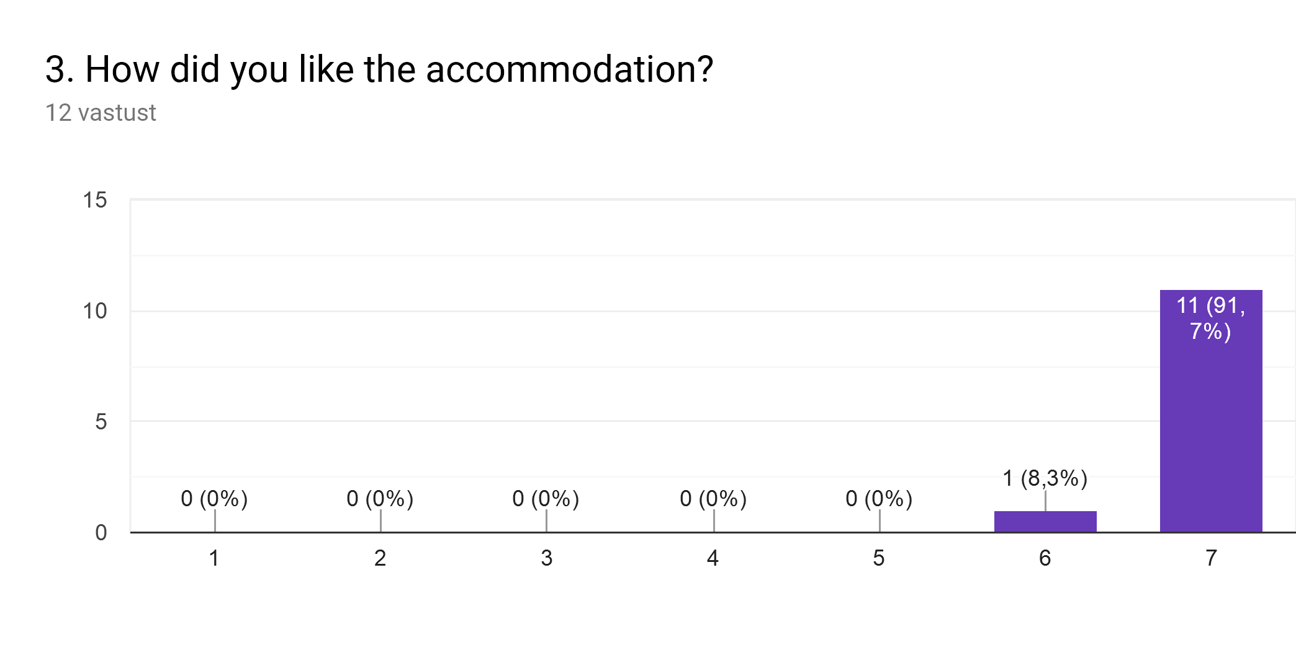

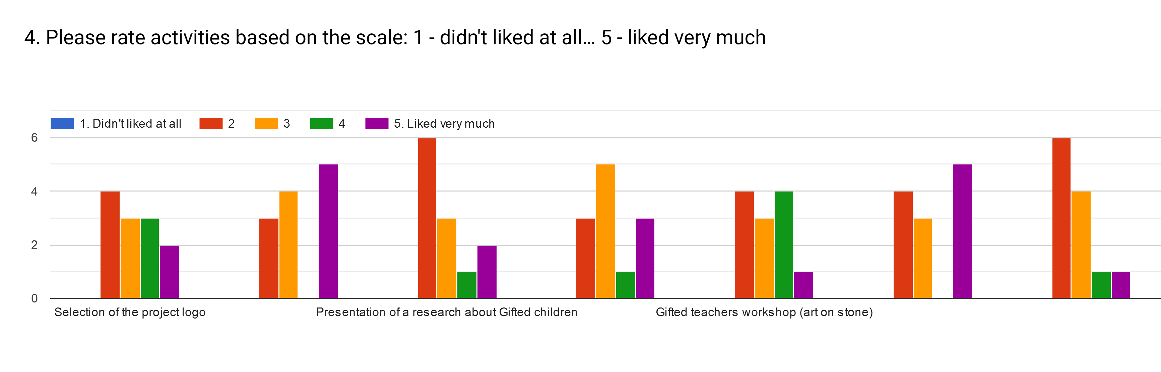

Most liked were:

Presentation of 5 famous scientists - liked very much: 5 votes

Film Forum „Gifted” - liked very much: 5 votes

Gifted teachers workshop (art on stone) - liked very much: 1 vote, liked it: 4 votes

Seminar in University of Thessaly "Gifted students: Features and teaching support" (by Stavroula Kaldi and Theodoros Kokkinos) - didn’t liked it: 6 votes, so and so: 4 votes

Presentation of a research about Gifted children - didn’t liked it: 6 votes, so and so: 3 votes

Comments:

I think we could have worked more on the film.

The film was very good but the technical support didn't allow us to see the subtitles. I think we couldn't understand it all

The beginning of activities draged, and it wasted our precious time.

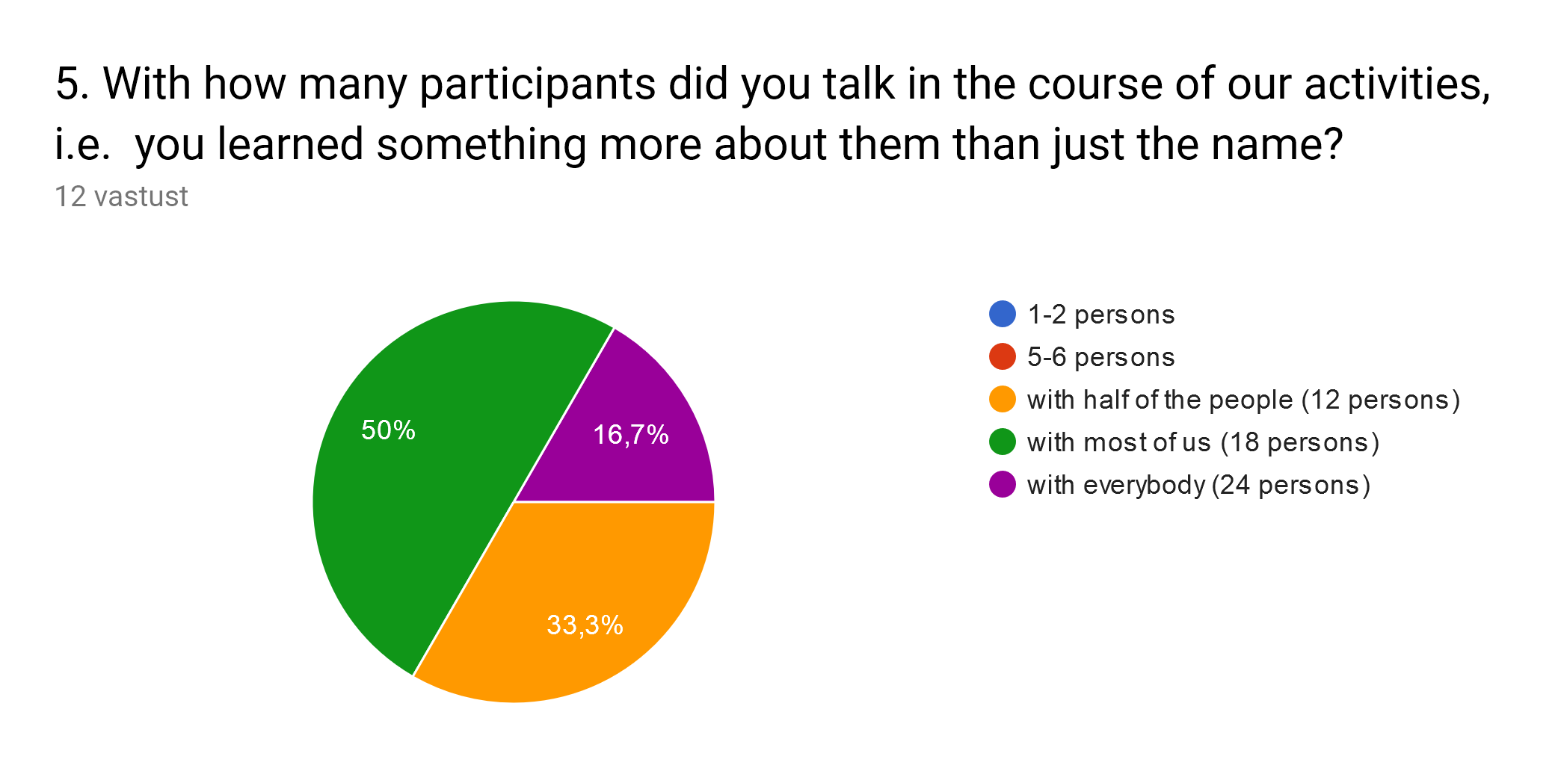

Comments:

Thanks to everyone

Some people is very shy. We should prepare some working teams with mixed groups.

Couldn`t talk to everybody, because some of us weren`t much communicative

For comparsion: from first meeting assesment

